**GUIDE TO CREATING YOUR NCCER ACCOUNT**

**GO TO NCCER.ORG and CLICK ON SIGN IN**

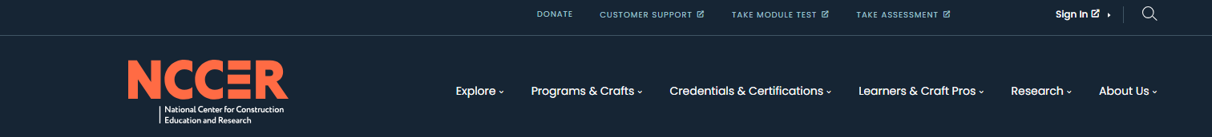

**ALL STUDENTS MUST CREATE AN ACCOUNT EVEN IF YOU HAVE AN EXISTING NCCER NUMBER. THIS IS MANDATORY. YOU WILL NOT BE ABLE TO ATTEND CLASS OR TAKE EXAMS WITHOUT HAVING A VALID ACCOUNT.  *THIS INFO IS DUE TO CRANES 101 AT LEAST 1 WEEK BEFORE CLASS STARTS***

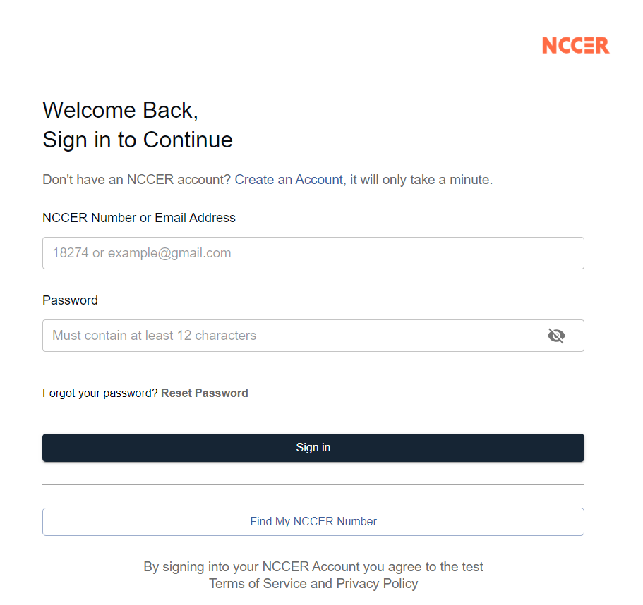

**IF YOU ARE A RECERTIFICATION CLICK HERE IF YOU DO NOT KNOW YOUR NCCER NUMBER**

For returning users once account has been set up

**FILL IN ALL FIELDS AND ACCEPT TERMS AND CONDITIONS, THEN PRESS CREATE ACCOUNT**

1. 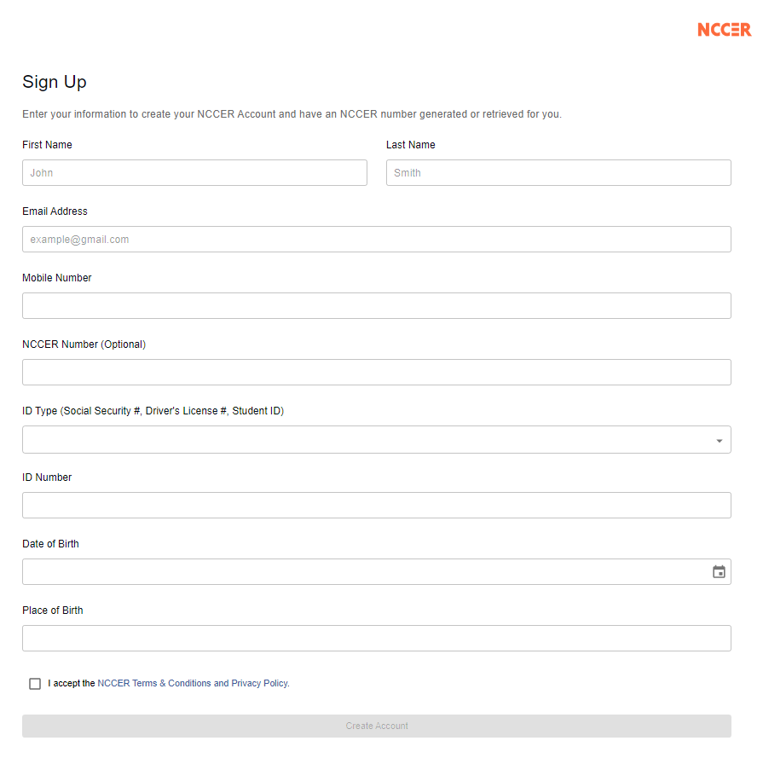

**If you have an existing NCCER number from before 2020 – you MUST enter your social security number to link with your original account.**

**DO NOT MAKE A NEW ACCOUNT! YOU WILL BE UNABLE TO TEST IF YOU ARE LINKED TO MORE THAN 1 ACCOUNT**

**If you have a NCCER number – enter it here when creating your account**

*This must be* **YOUR** *email address as you will need to access it to complete the registration process*

**YOUR NCCER NUMBER WILL SHOW HERE - YOU MUST SEE THIS SCREEN TO CONFIRM YOUR REGISTRATION WAS DONE PROPERLY**

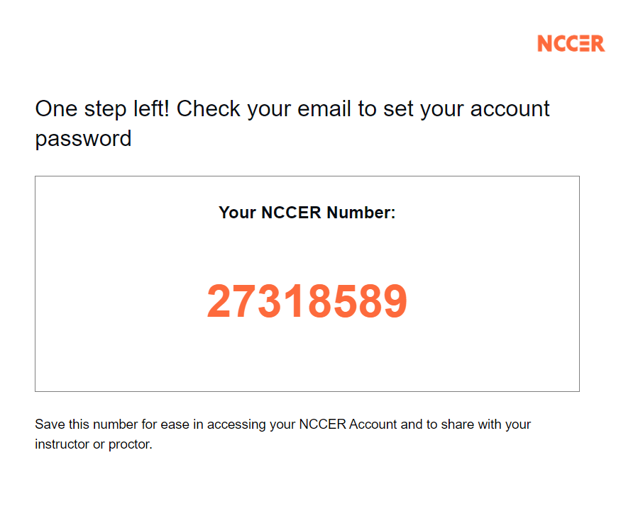

**THIS NUMBER MUST BE INCLUDED ON THE CLASS REGISTRATION PAPERWORK SO THAT EXAMS CAN BE ORDERED AND ASSIGNED**

*BLOCKED FOR PRIVACY*

**PLEASE CREATE A PASSWORD THAT YOU CAN EITHER REMEMBER OR BRING IT WITH YOU TO THE CLASS. IF YOU DO NOT CREATE A PASSWORD, WE WILL ASSIGN A DEFAULT PASSWORD TO ALLOW YOU ACCESS TO THE TEST AND FOR US TO UPLOAD YOUR PHOTO**

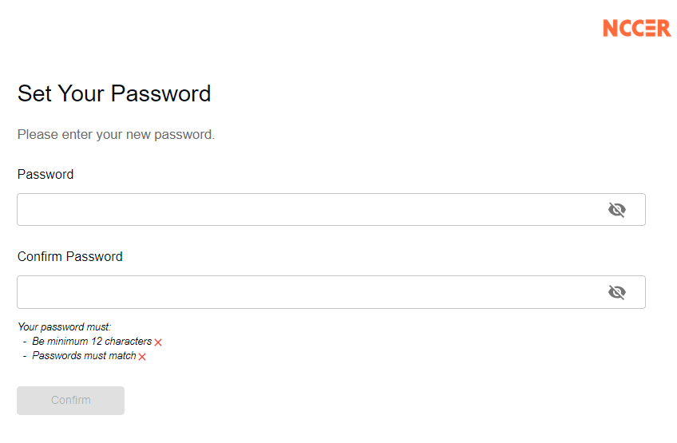

**NOW CHECK YOUR EMAIL**

The email address you just accessed

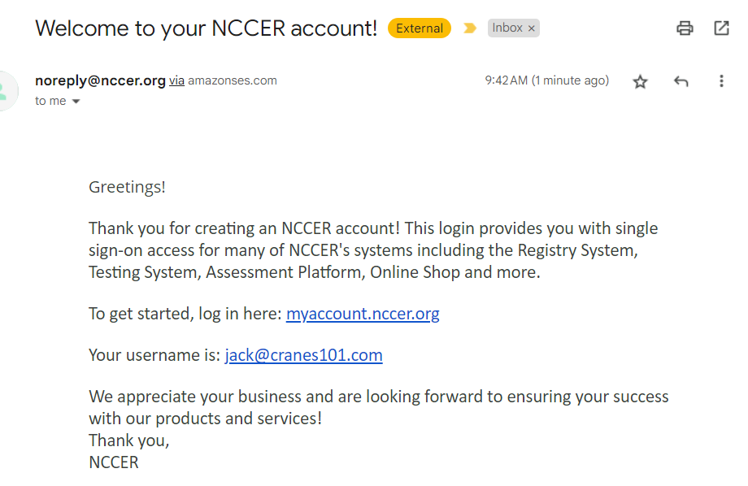

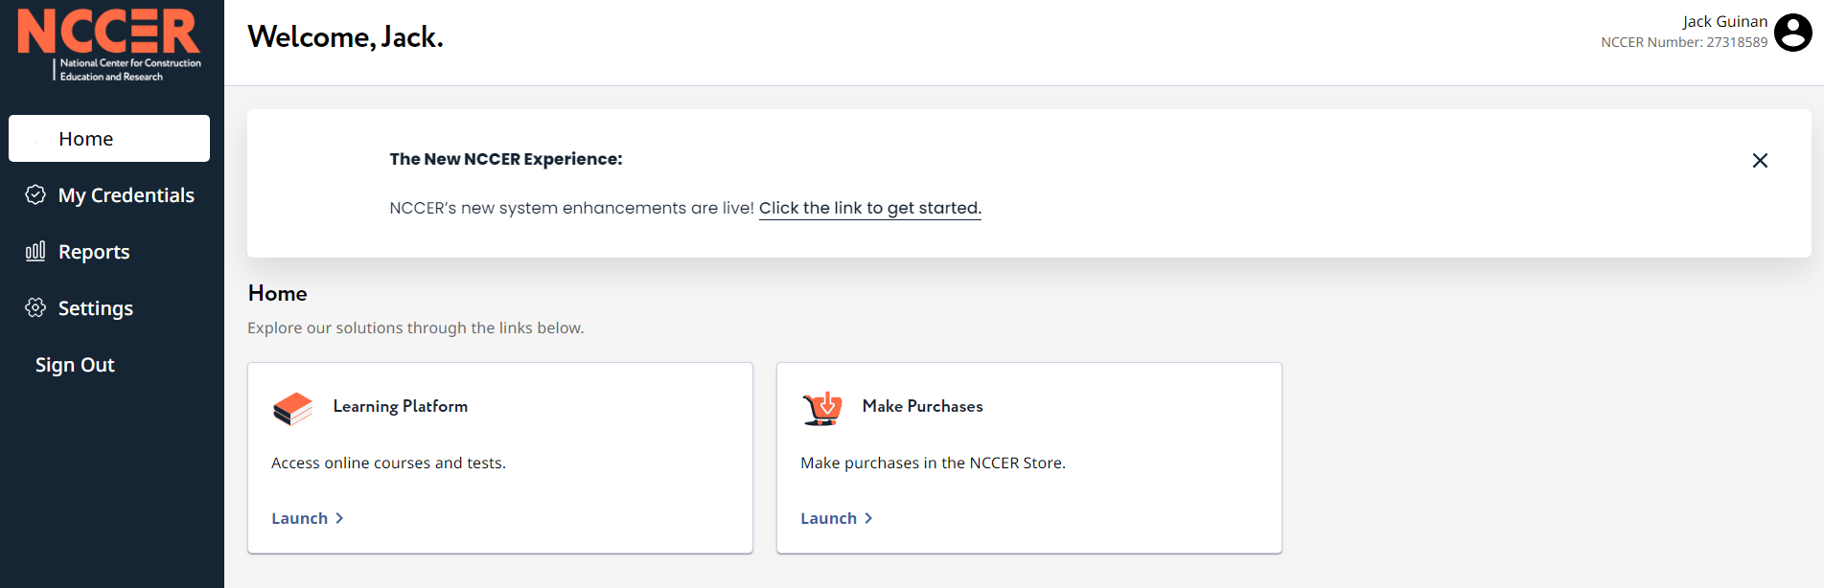

Your name and NCCER number will be here

**GO TO SETTINGS TO UPLOAD YOUR PHOTO & CLICK ON EDIT PROFILE**

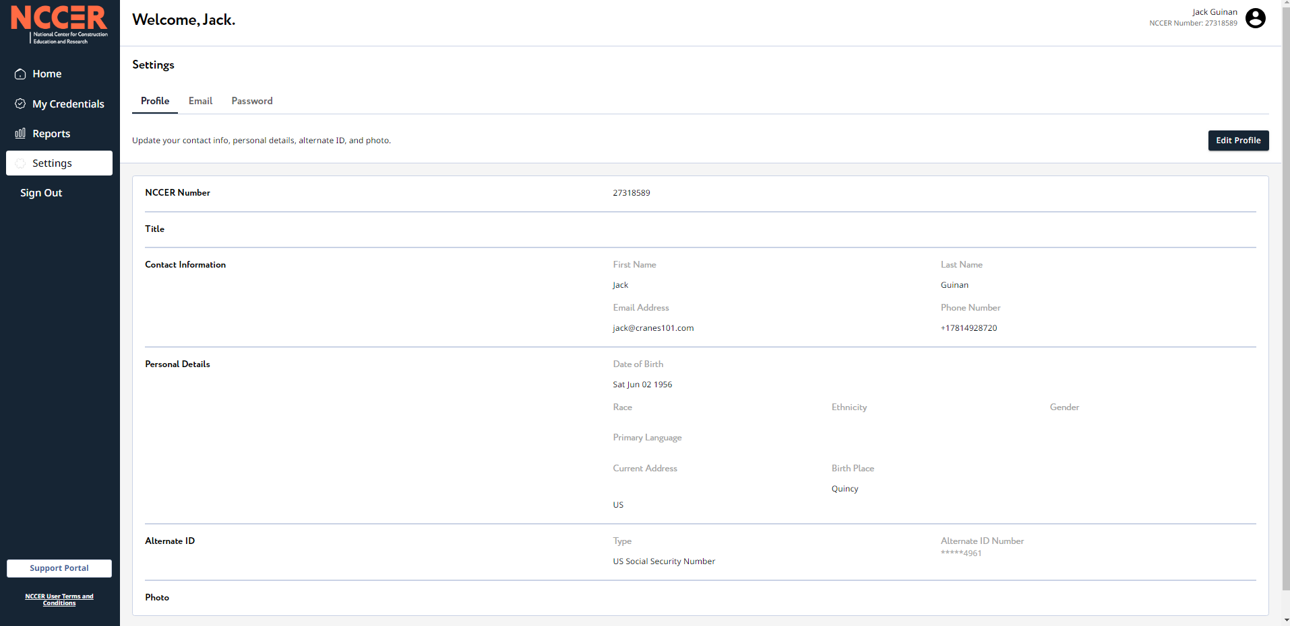

**CLICK HERE TO UPLOAD THE PHOTO**

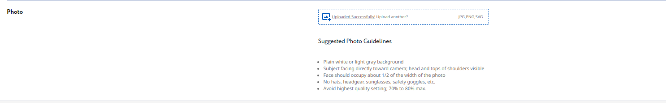

**FOLLOW THE GUIDELINES AND LOCATE PHOTO IN YOUR FILES.**

**DOUBLE CLICK ON THE PHOTO OR CLICK ON IT AND THEN HIT OPEN**

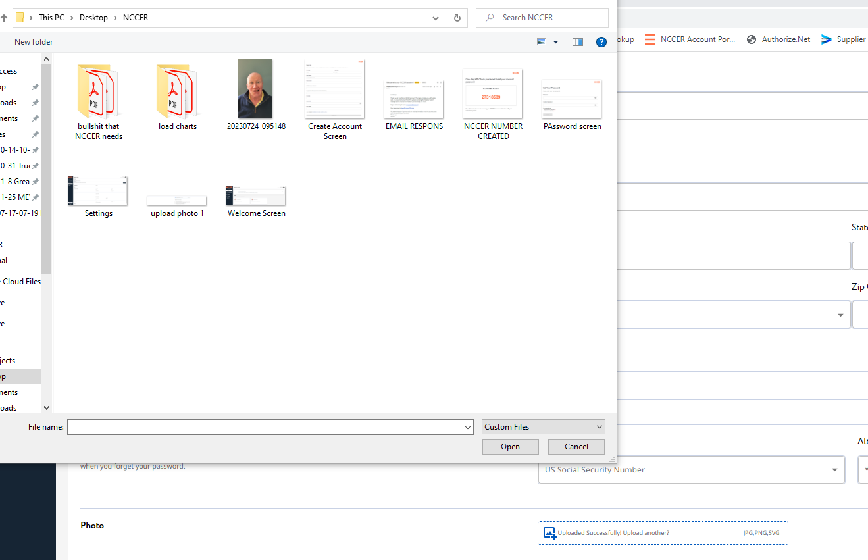

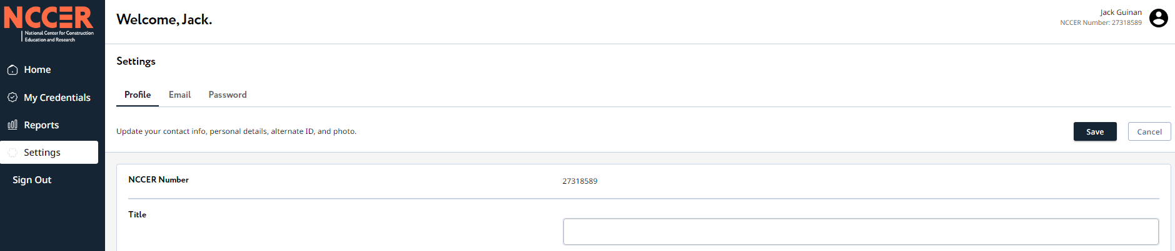

**CLICK HERE TO SAVE**

**BE SURE PHOTO IS SUCCESSFUL.**

**YOUR CERTIFICATIONS ARE NOT VALID UNTIL A PHOTO IS SUBMITTED**

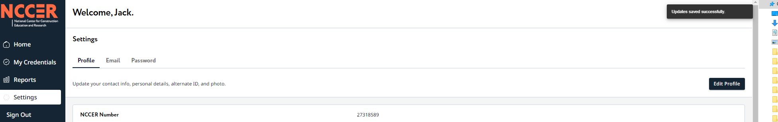

**You will now see your photo in the upper left with your name and NCCER #**

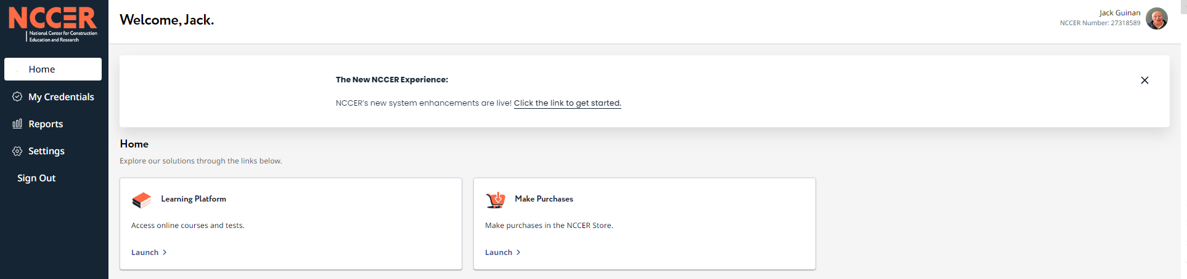

*******************************************************************

This process should take about 5-10 minutes. If you are having difficulty with account creation, please contact NCCER at 888-622-3720 or support@nccer.org.

Photo upload is mandatory as your certifications are a 3 step process which includes passing the written exam, the practical exam AND an acceptable photo.

**No photo or rejected photo means you are NOT certified.**

Our instructors will still take photos at the class. If you need a copy of the photo to upload contact our office and we will send it to you. Or you can include your account password on the registration form and Cranes101 will upload the photo for you.